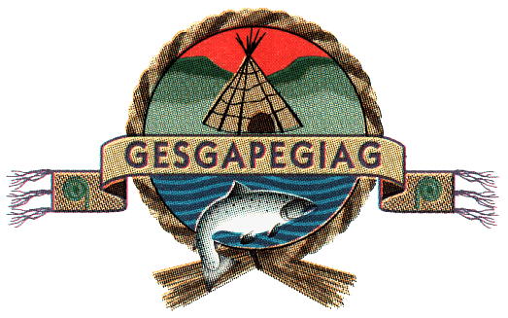
Council meeting
February 23rd, 2026
10:00 a.m.
Gpnol’ewoguom Conference Room
10A School Street

- Approval of the Agenda
- Approval of minutes dated February 11th, 2026
- Business arising from minutes/DG’s update
- Decision Note: Submission of Aboriginal-Led Protected Area Projects by the Micmac Nation of Gesgapegiag. BCR# 2063

- Decision Note: Approval to acquire a replacement vessel for 2026-2027 midshore operations. BCR# 2064

- Request from Human Resources Generalist

- Chief’s Update

