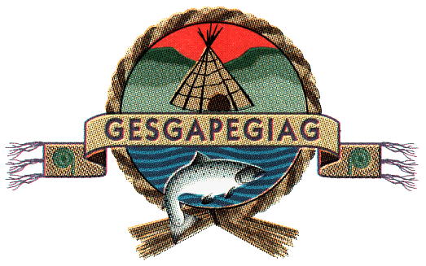
Council meeting
March 16th, 2026
10:00 a.m.
Gpnol’ewoguom Conference Room
10A School Street

- Approval of the Agenda

- Approval of minutes dated February 23rd, 2026

- Business arising from minutes/DG’s update

- Decision Note: To implement Consumer Proce Index Increase for April 1st, 2026

- Decision Note: Characterization of Thermal Refuges (cold water sources) the Cascapedia River for Plamu Habitat Projection and Stream Crossing Training

- Decision Note: Wisgog through a Mi’gmaq Lens

- Decision Note: MCC Agreement Funding application from the Ministere de Culture et Communication

- Decision Note: Purchase of Refrigerated Van for lobster Transport

- Decision Note: Approval of Specific Claims Application

- Information Note: Cultural Exchange networking

- Financial Administration Law

- Hiring Report from Human Resources Generalist

- Chief’s Update

