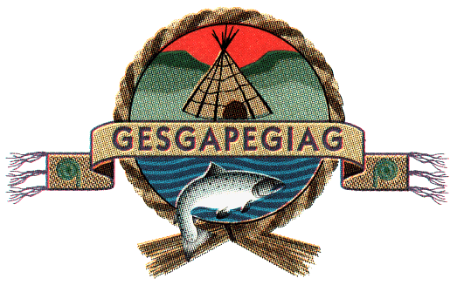
Council meeting
June 8th, 2026
10:00 a.m.
Gpnol’ewoguom Conference Room
10A School Street

- Approval of the Agenda

- Approval of minutes dated May 27th, 2026

- Business arising from minutes/DG’s update

- Decision Note: Tourism Marketing Initiative

- Information Note: Marketing Project

- Decision Note: Future partnership with First Nations Market Housing Fund

- Decision Note: Extension to the Daycare building

- Band Council Resolution # 2080 Ministerial Guarantee

- TD Bank Group-Proposal for Banking Services

- Land Use Occupancy Report

- Hiring Report from Human Resources Generalist

- Chief’s Update

